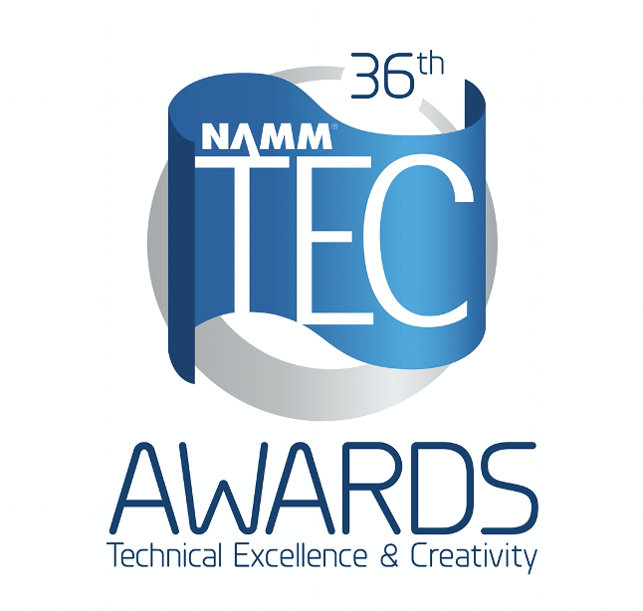

Nominated Company Logo Here]

[Product/Project] Nominated for NAMM TEC Award for Outstanding [Creative/Technical] Achievement

CITY, STATE – DATE – [NAME OF COMPANY/PROJECT] has been announced as a nominee for the 36th Annual NAMM Technical Excellence & Creativity (TEC) Awards in the category of Outstanding [Technical/Creative] Achievement. Presented by The NAMM Foundation, The NAMM TEC Awards are bestowed annually in celebration of the pro audio community by recognizing the individuals, companies and technical innovations behind today’s sound recordings, live performances, films, television, video games and other media.

[“Quote from executive on why he/she is honored to have this nomination and what it means to them,” said Name, title, at Business Name.]

The nomination announcement follows a four-month call for entries of standout technical and creative products and projects that have made a significant impact on modern sound and music. A panel of respected industry voters from pro audio publications as well as members of professional music, technical and creative organizations, along with select NAMM members carefully evaluated each entry before selecting [product name/project here] for the nomination.

[Winning product/project details and other recent organization/company news inserted here.]

The NAMM TEC Awards will be held in January 2021 in conjunction with Believe in Music Week, the global, online gathering to unite and support the people who bring music to the world. Learn more about the TEC Awards at www.tecawards.org.

MEDIA CONTACT:
[CONTACT NAME]
[CONTACT PHONE]
[CONTACT EMAIL]

[ABOUT THE NOMINATED COMPANY]

ABOUT THE TEC AWARDS
Presented annually by the NAMM Foundation during The NAMM Show, The NAMM TEC Awards recognize the individuals, companies and technical innovations behind the sound of recordings, live performances, films, television, video games and other media in 31 Technical and Creative Achievement Categories. The Les Paul Award is given at the event in tribute to musical artists and others whose work has exemplified the creative application of audio technology. Through its Hall of Fame, The TEC Awards also honors the pioneers of audio technology and the music industry’s most accomplished producers and audio technicians. The NAMM Foundation’s TECnology Hall of Fame celebrates innovations and ground breaking technical achievements of the past. For more information, visit www.tecawards.org

About NAMM
The National Association of Music Merchants (NAMM) is the not-for-profit association with a mission to strengthen the $17 billion music products industry. NAMM is comprised of approximately 10,400 members located in 104 countries and regions. NAMM events and members fund The NAMM Foundation's efforts to promote the pleasures and benefits of music, and advance active participation in music making across the lifespan. For more information about NAMM, please visit www.namm.org, call 800.767.NAMM (6266) or follow the organization on Facebook, Instagram and Twitter.

###

